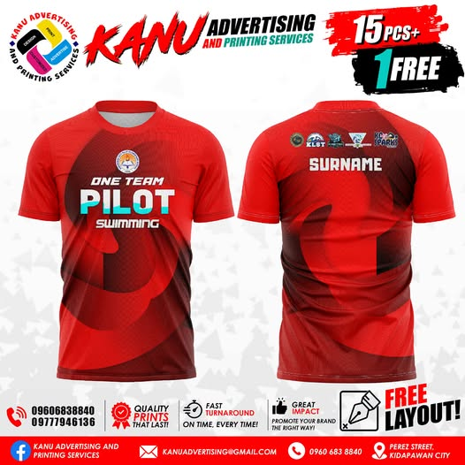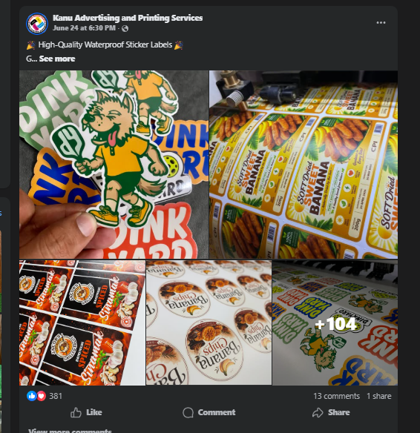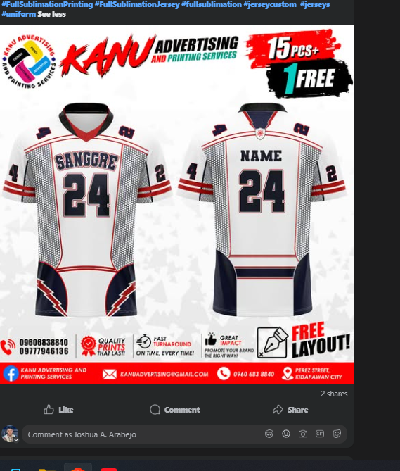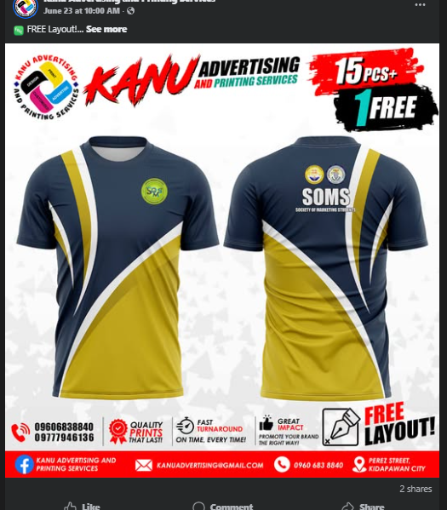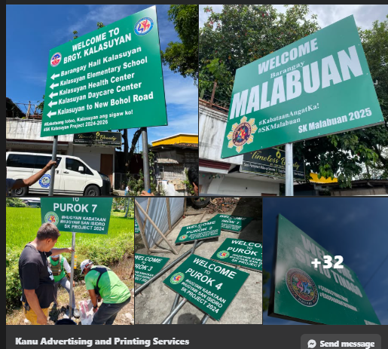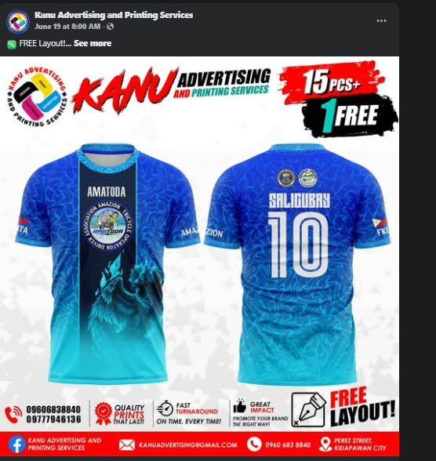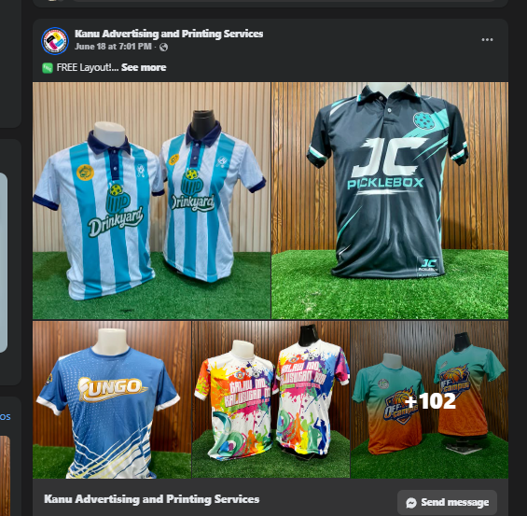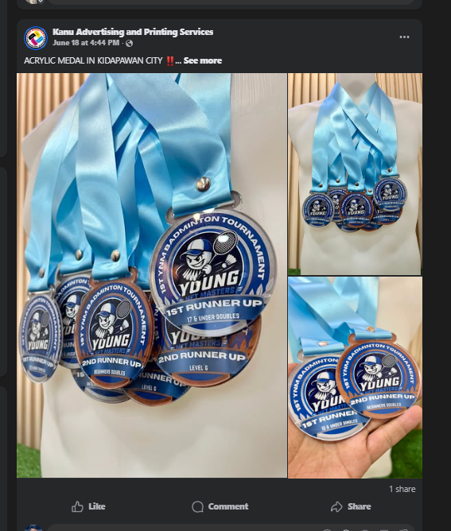

ACRYLIC MEDAL IN KIDAPAWAN CITY
Our Acrylic Trophies Are Ideal For:
Graduations
Awarding Ceremonies
Motorshow Award
Sports Competitions
and Tournaments
Business and Industry
related awards
Academic Achievements
And many others!
We also provide BIG DISCOUNTS FOR BULK ORDERS
SHOP LOCATION
Come and drop by our newest home at 𝐊𝟒𝐋 𝐁𝐮𝐢𝐥𝐝𝐢𝐧𝐠, 𝐆𝐫𝐨𝐮𝐧𝐝 𝐟𝐥𝐨𝐨𝐫 𝐃𝐚𝐲𝐚𝐨 𝐒𝐭. 𝐏𝐨𝐛𝐥𝐚𝐜𝐢𝐨𝐧 𝐊𝐢𝐝𝐚𝐩𝐚𝐰𝐚𝐧 𝐂𝐢𝐭𝐲 !
Shop is open 8:00 AM to 5:00 PM Monday to Saturday
For inquiries call or text:
09606838840
(064) 248 - 0926
Facebook Page:
Kanu Advertising and Printing Services
#medal #acrylicmedal #acrylic #K

ACRYLIC MEDAL IN KIDAPAWAN CITY
Our Acrylic Trophies Are Ideal For:
Graduations
Awarding Ceremonies
Motorshow Award
Sports Competitions
and Tournaments
Business and Industry
related awards
Academic Achievements
And many others!
We also provide BIG DISCOUNTS FOR BULK ORDERS
SHOP LOCATION
Come and drop by our newest home at 𝐊𝟒𝐋 𝐁𝐮𝐢𝐥𝐝𝐢𝐧𝐠, 𝐆𝐫𝐨𝐮𝐧𝐝 𝐟𝐥𝐨𝐨𝐫 𝐃𝐚𝐲𝐚𝐨 𝐒𝐭. 𝐏𝐨𝐛𝐥𝐚𝐜𝐢𝐨𝐧 𝐊𝐢𝐝𝐚𝐩𝐚𝐰𝐚𝐧 𝐂𝐢𝐭𝐲 !
Shop is open 8:00 AM to 5:00 PM Monday to Saturday
For inquiries call or text:
09606838840
(064) 248 - 0926
Facebook Page:
Kanu Advertising and Printing Services
#medal #acrylicmedal #acrylic #K

FREE Layout!
HIGH QUALITY !
Order 15 Jerseys, Get 1 FREE — Just Because You Deserve It!
Express Yourself in Style — If You Can Dream It, We Can Print It!
Vibrant Colors. Fade-Proof Drip.
Top-Tier Prints Powered by Mimaki Technology
The More You Buy, The More You Save — No Cap
Kidapawan! Full-Color Sublimation Is Now Just Around the Corner!
Come and drop by our newest home at 𝐊𝟒𝐋 𝐁𝐮𝐢𝐥𝐝𝐢𝐧𝐠, 𝐆𝐫𝐨𝐮𝐧𝐝 𝐟𝐥𝐨𝐨𝐫 𝐃𝐚𝐲𝐚𝐨 𝐒𝐭. 𝐏𝐨𝐛𝐥𝐚𝐜𝐢𝐨𝐧 𝐊𝐢𝐝𝐚𝐩𝐚𝐰𝐚𝐧 𝐂𝐢𝐭𝐲 !

Cladding / Barangay Signages in Kidapawan City
FREE LAYOUT
Quality
Affordable
Customized
BIG DISCOUNTS for bulk orders? We got you covered!
SHOP LOCATION
Come and drop by our newest home at 𝐊𝟒𝐋 𝐁𝐮𝐢𝐥𝐝𝐢𝐧𝐠, 𝐆𝐫𝐨𝐮𝐧𝐝 𝐟𝐥𝐨𝐨𝐫 𝐃𝐚𝐲𝐚𝐨 𝐒𝐭. 𝐏𝐨𝐛𝐥𝐚𝐜𝐢𝐨𝐧 𝐊𝐢𝐝𝐚𝐩𝐚𝐰𝐚𝐧 𝐂𝐢𝐭𝐲 !
Visit us at Perez Street, Poblacion, Kidapawan City (near old terminal, beside Mt. Apo Birthing Place)
Shop hours: Mon-Sat, 8am-5pm
Call/Text: +639777946136 / 09606838840 | Facebook Page: Kanu Advertising and Printing Services
#cladding #signage #outdoorstickers #sticker #kidapawan #SangguniangKabataan2024 #SangguniangKabataan #barangay #barangaysignage
See less

